Jim Brendlinger

CSI 117

2/4/2015

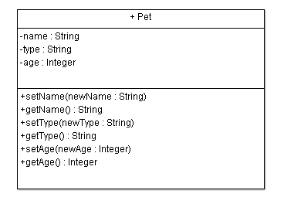

Class Pet

Private String name

Private String type

Private Integer age

Display “What is the name of your pet?”

Input name

Display “What is the species of your pet?”

Input type

Display “What is the age of your pet?”

Input age

Public Module setName (String newName)

Set newName

End Module

Public Function String getName()

Return name

End Function

Public Module setType (String newType)

Set newType

End Module

Public Function String getType()

Return type

End Function

Public Module setAge(Integer newAge)

Set newAge

End Module

Public Function Integer getAge()

Return age

End Function

Display “The kind of pet you have is a “, newType

Display “The age of your pet is “, newAge

Display “The name of your pet is “, newName